**D.Y. PATIL INSTITUTE OF MASTER OF COMPUTER APPLICATION AND MANAGEMENT**

**(Akurdi, Pune)**



Title of the Project :

**MUSICAL INSTRUMENTS SYSTEM**

Submitted by *,*

**149_Dhananjay Bhagat**

**143_Aniket Margane**

Class :

**F.Y.MCA(2022-23)**

* **Data Flow Diagram :-**

**Level 0 :**

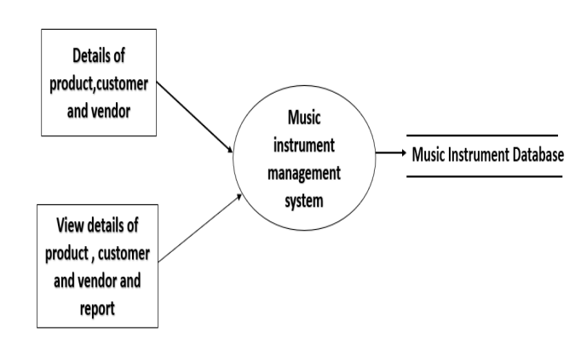

**Level 1 :**

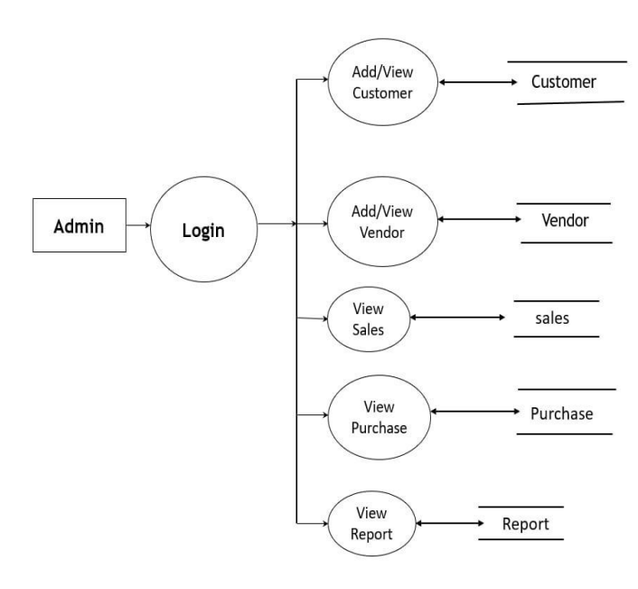

* **Entity Relationship Diagram :-**

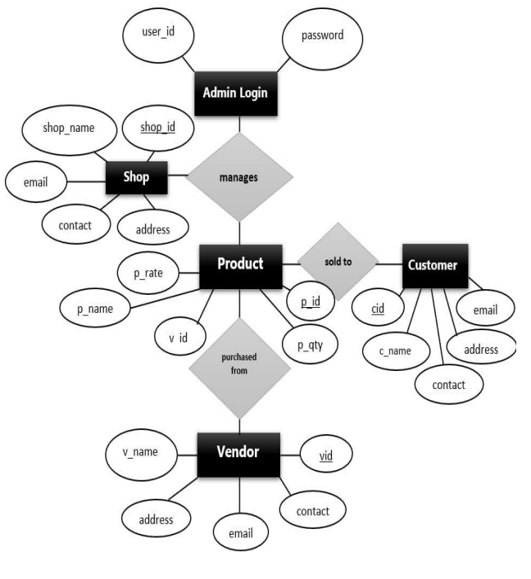

* **Use Case Diagram :-**

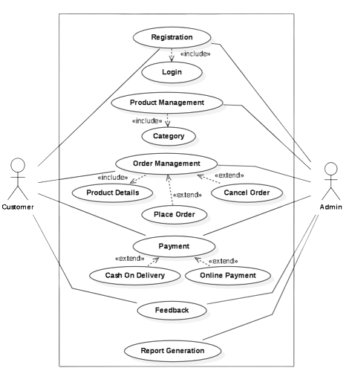

* **Activity Diagram :-**

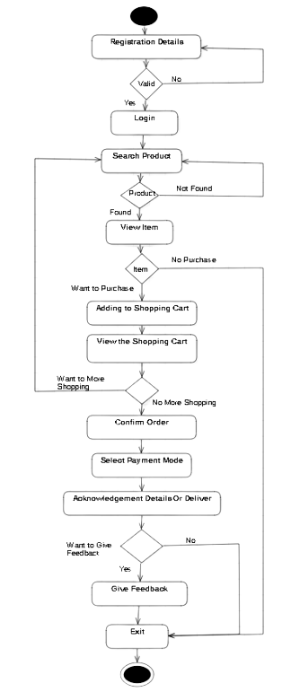

* **Sequence Diagram :-**

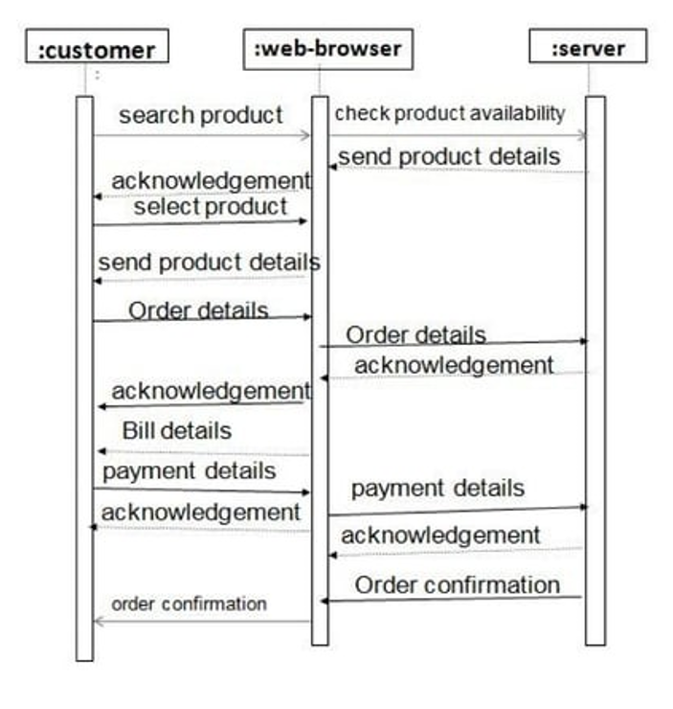

* **Class Diagram :-**

